**Experiment – 1-2**

**Aim: Write a Python Program to find the roots of the equation by using Bisection Method.**

**Tools Used: Python 3.13.2**

**Program:**

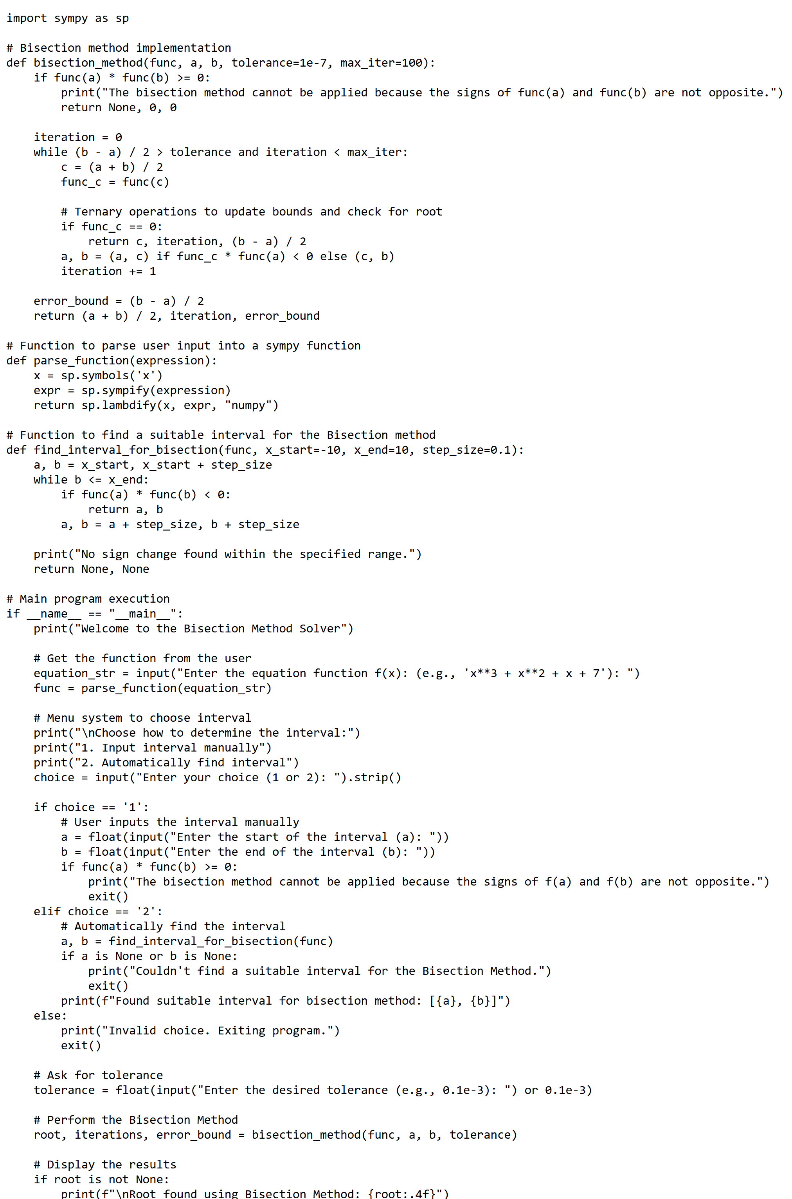

**Output:**

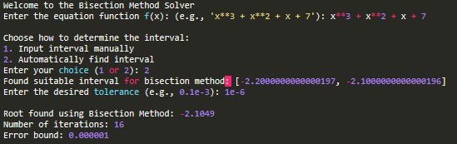

**Experiment – 3-4**

**Aim: Write a Python Program to find the roots of the equation by using Secant or Regula Falsi Method.**

**Tools Used: Python 3.13.2**

**Program:**

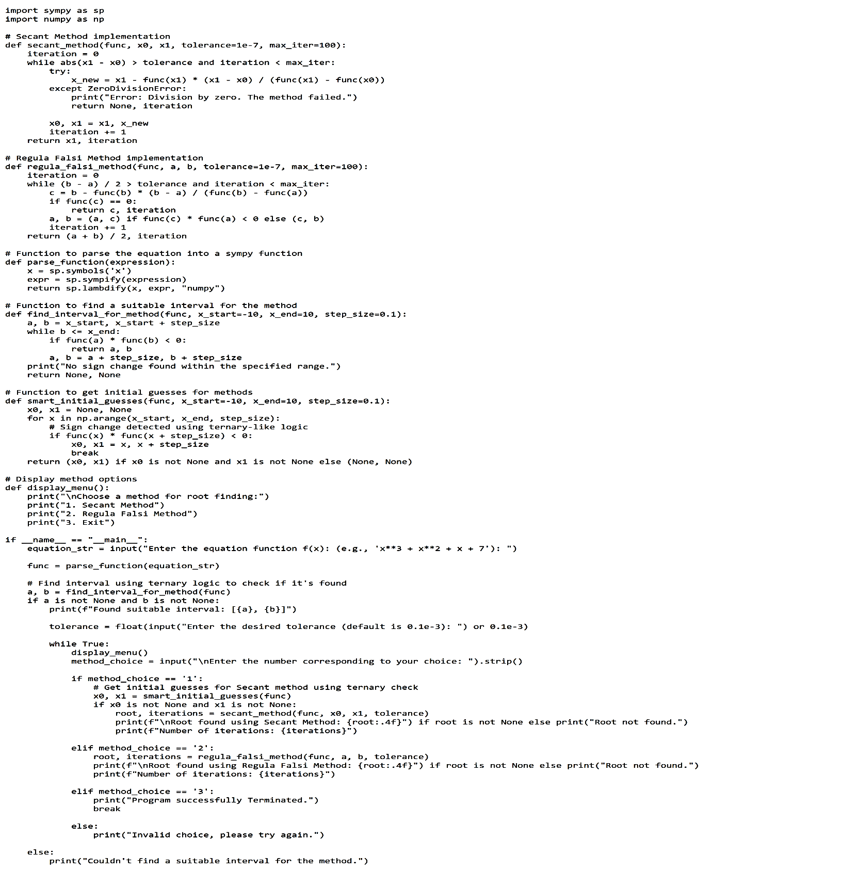

**Output:**

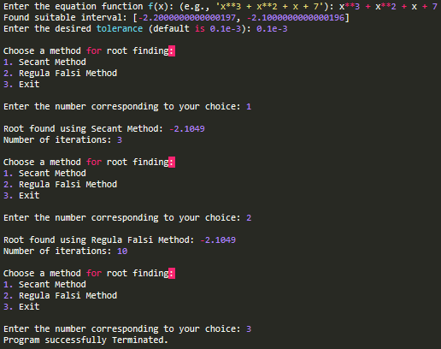

**Experiment – 5-6**

**Aim: Write a Python Program to find the roots of the equation by using Newton Raphson Method.**

**Tools Used: Python 3.13.2**

**Program:**

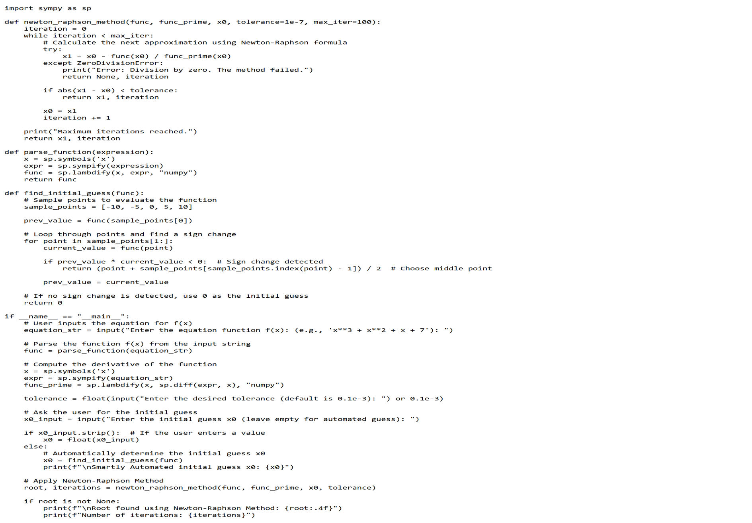

**Output:**

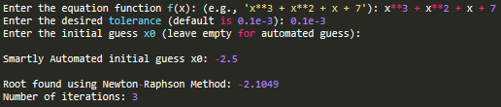

**Experiment – 7-8**

**Aim: Write a Python Program to find the solution of a system of nonlinear equation by using Newton's method.**

**Tools Used: Python 3.13.2**

**Program:**

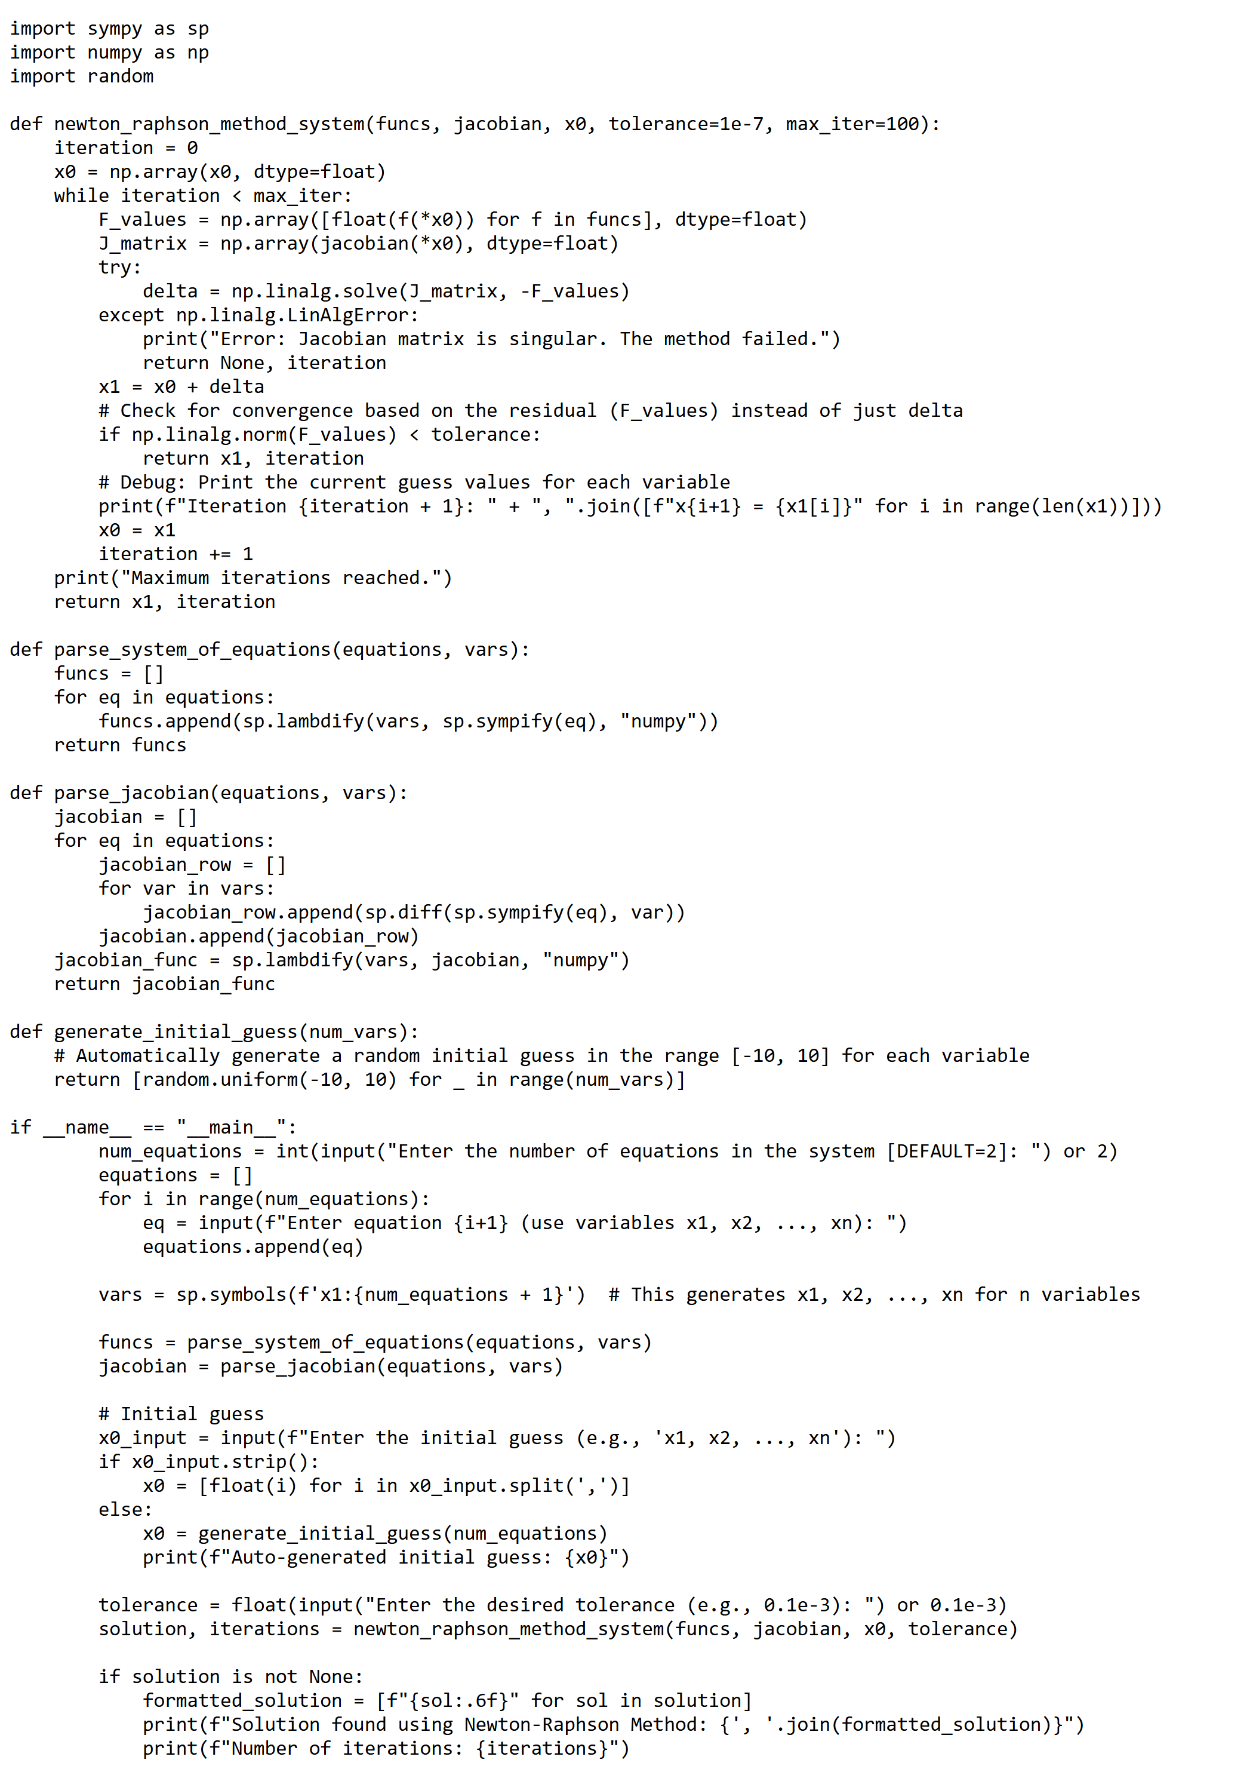

**Output:**

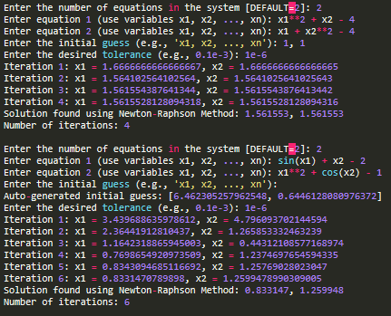

**Experiment – 9-10**

**Aim: Write a Python Program to find the solution of tri-diagonal system by using Gauss Thomas method.**

**Tools Used: Python 3.13.2**

**Program:**

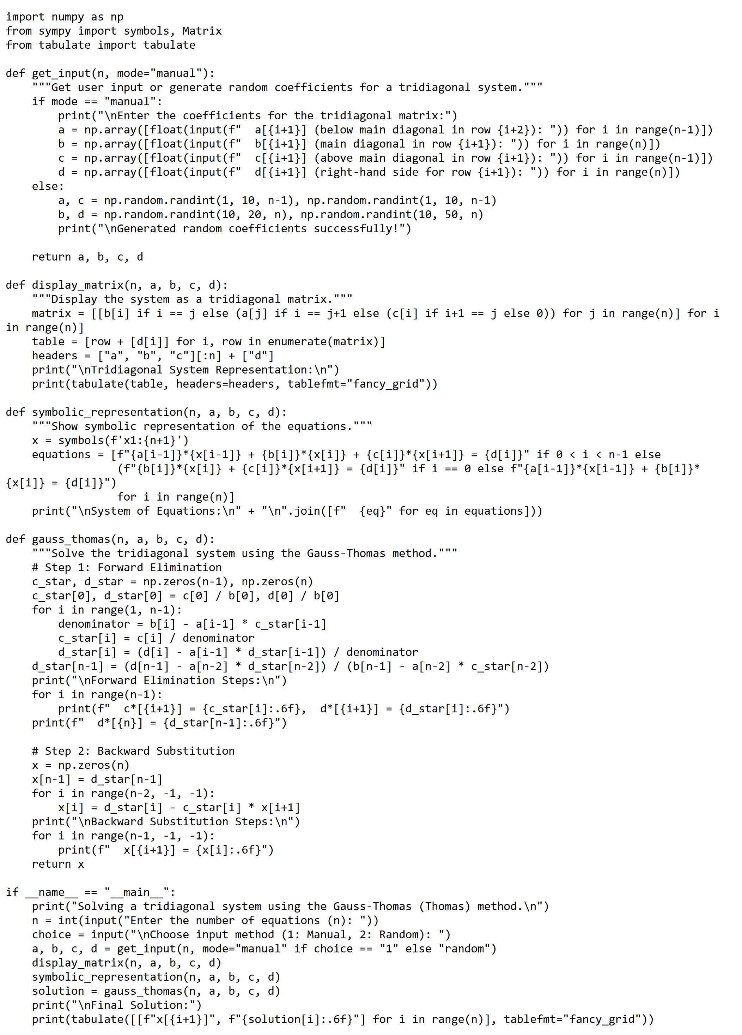

**Output:**

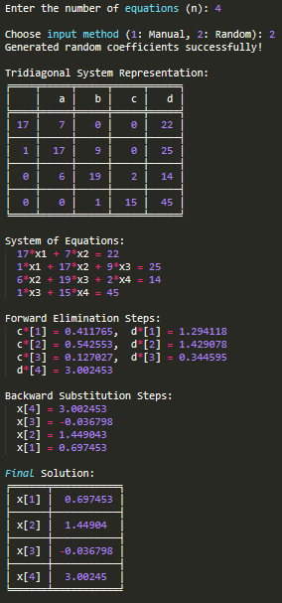

**Experiment – 11-12**

**Aim: Write a Python Program to find the solution of a system of equations by using Jacobi/Gauss-Seidel method.**

**Tools Used: Python 3.13.2**

**Program:**

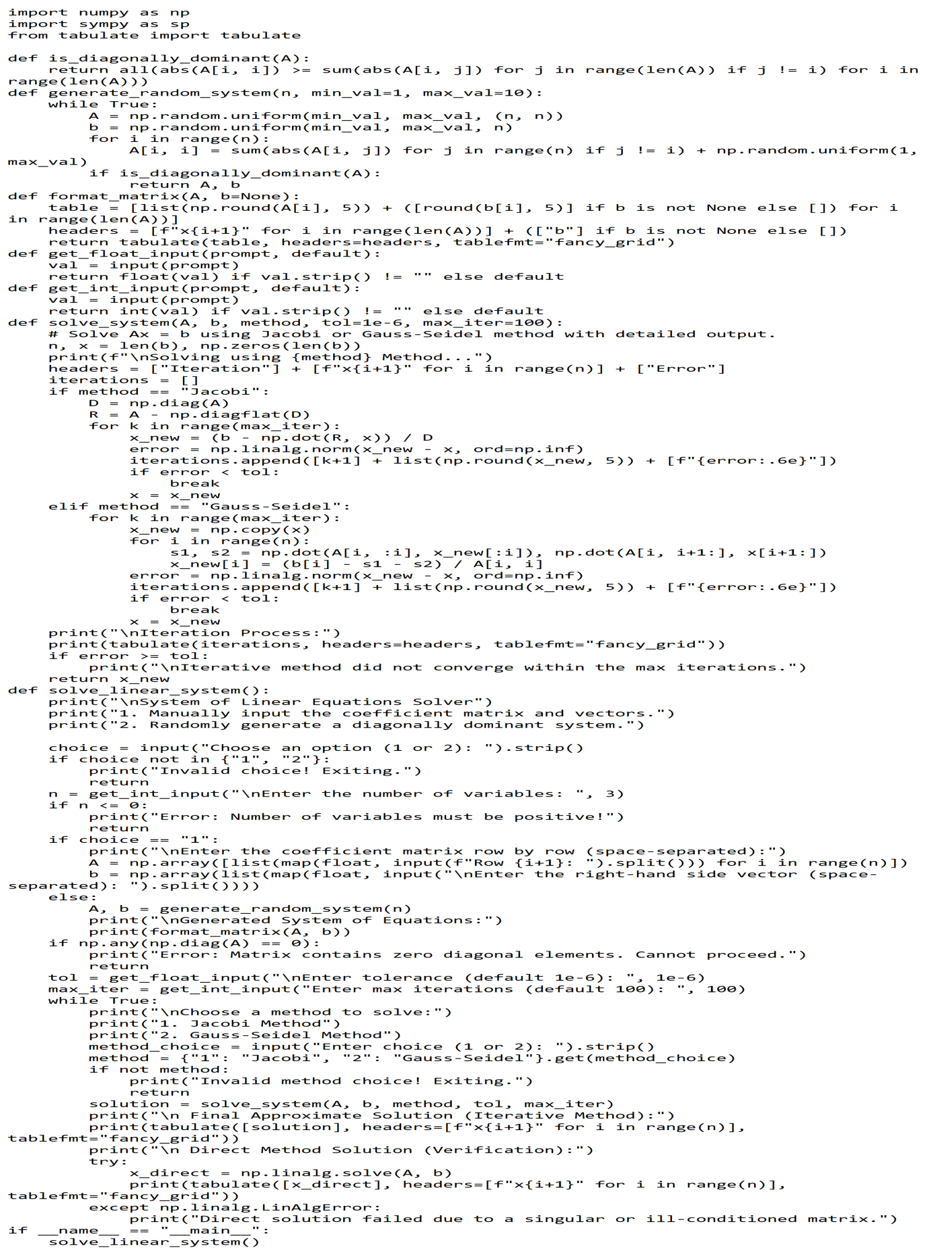

**Output:**

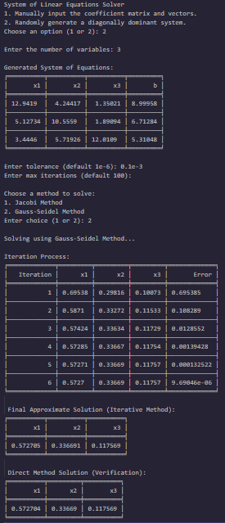

**Experiment – 13-14**

**Aim: Write a Python Program to find the cubic spine interpolating function.**

**Tools Used: Python 3.13.2**

**Program:**

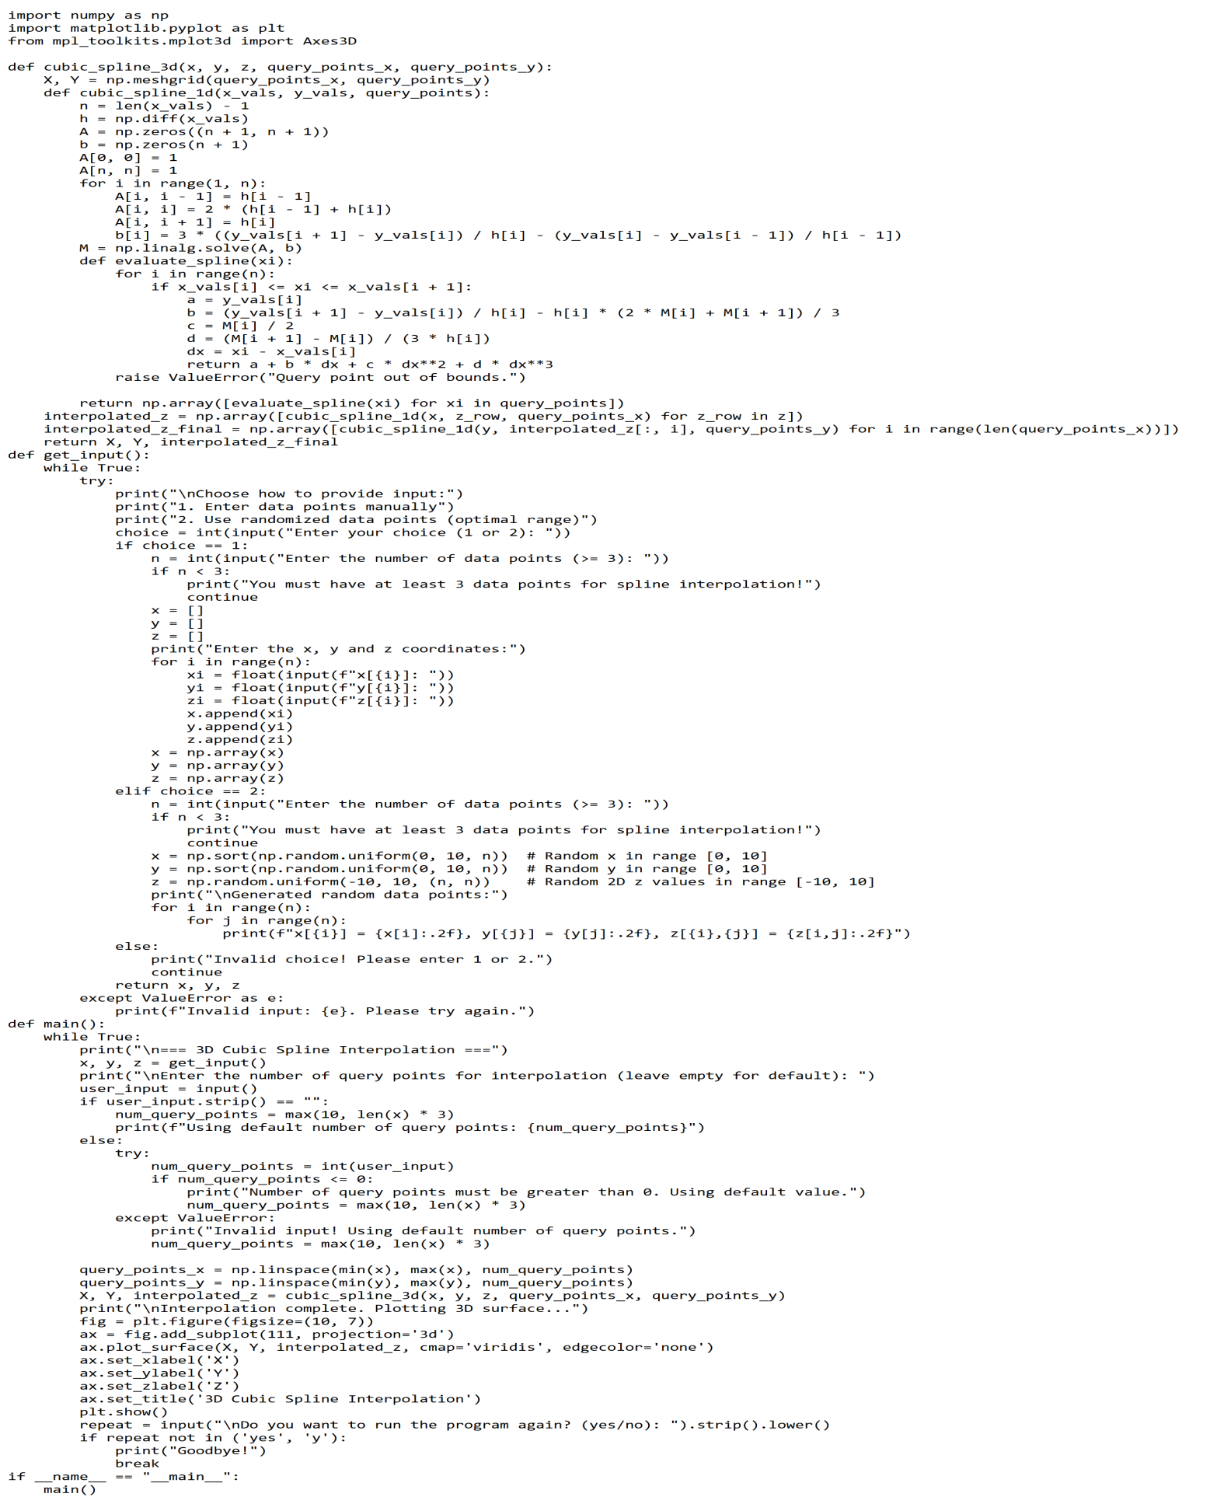

**Output:**

**Experiment – 15-16**

**Aim: Write a Python Program to evaluate the approximate value of finite integrals using Gaussian/Romberg integration.**

**Tools Used: Python 3.13.2**

**Program:**

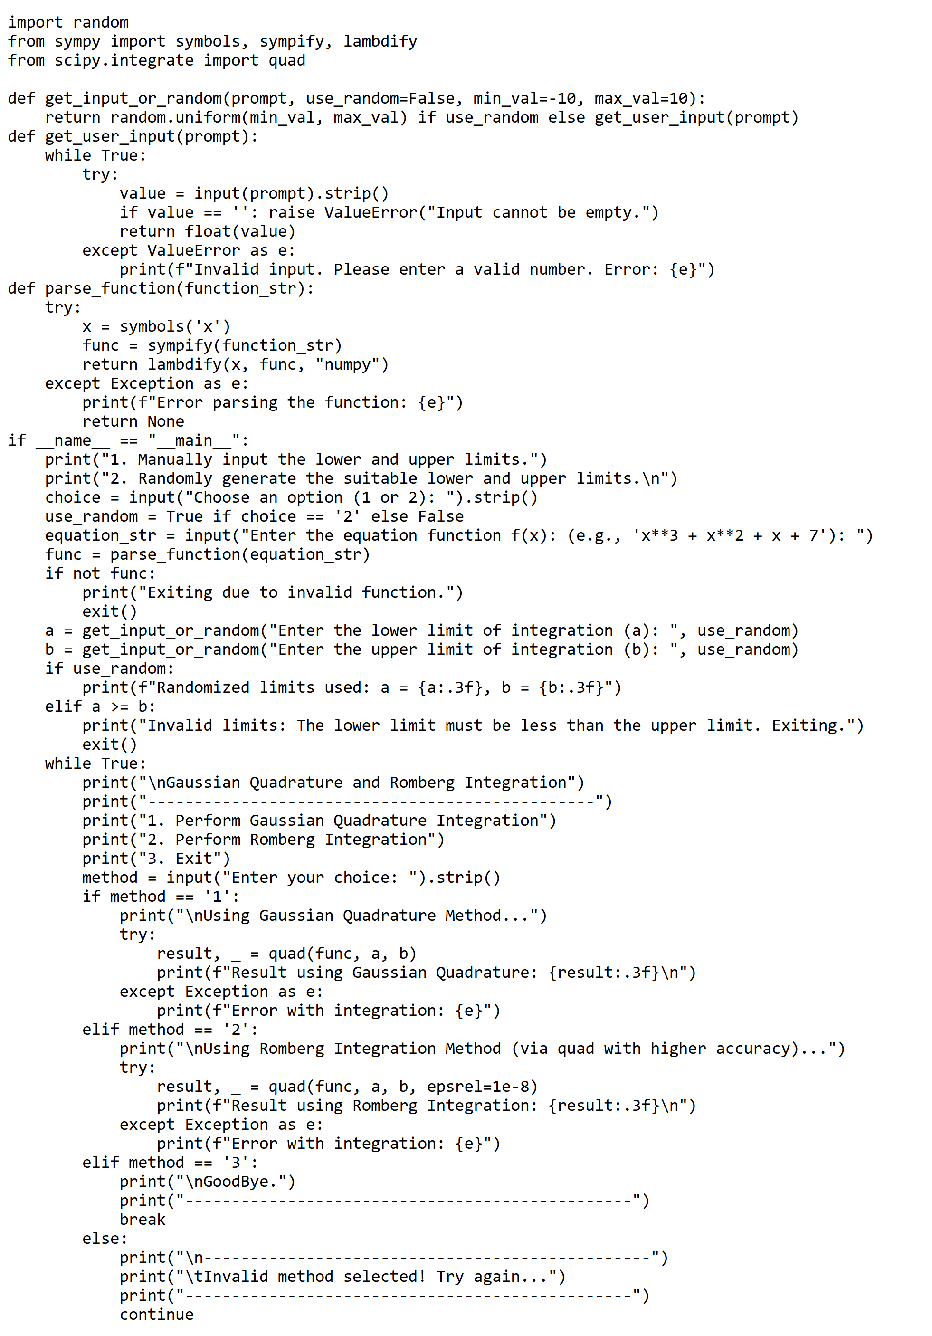

**Output:**

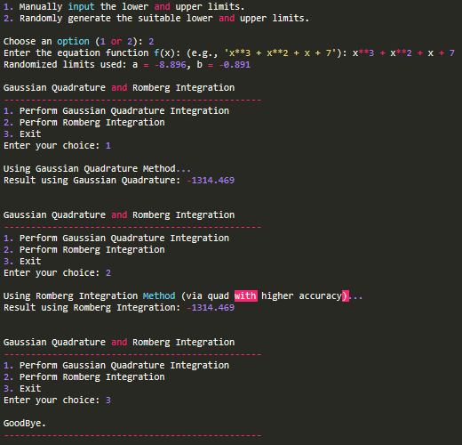

**Experiment – 17-18**

**Aim: Write a Python Program to solve the boundary value problem using finite difference method.**

**Tools Used: Python 3.13.2**

**Program:**

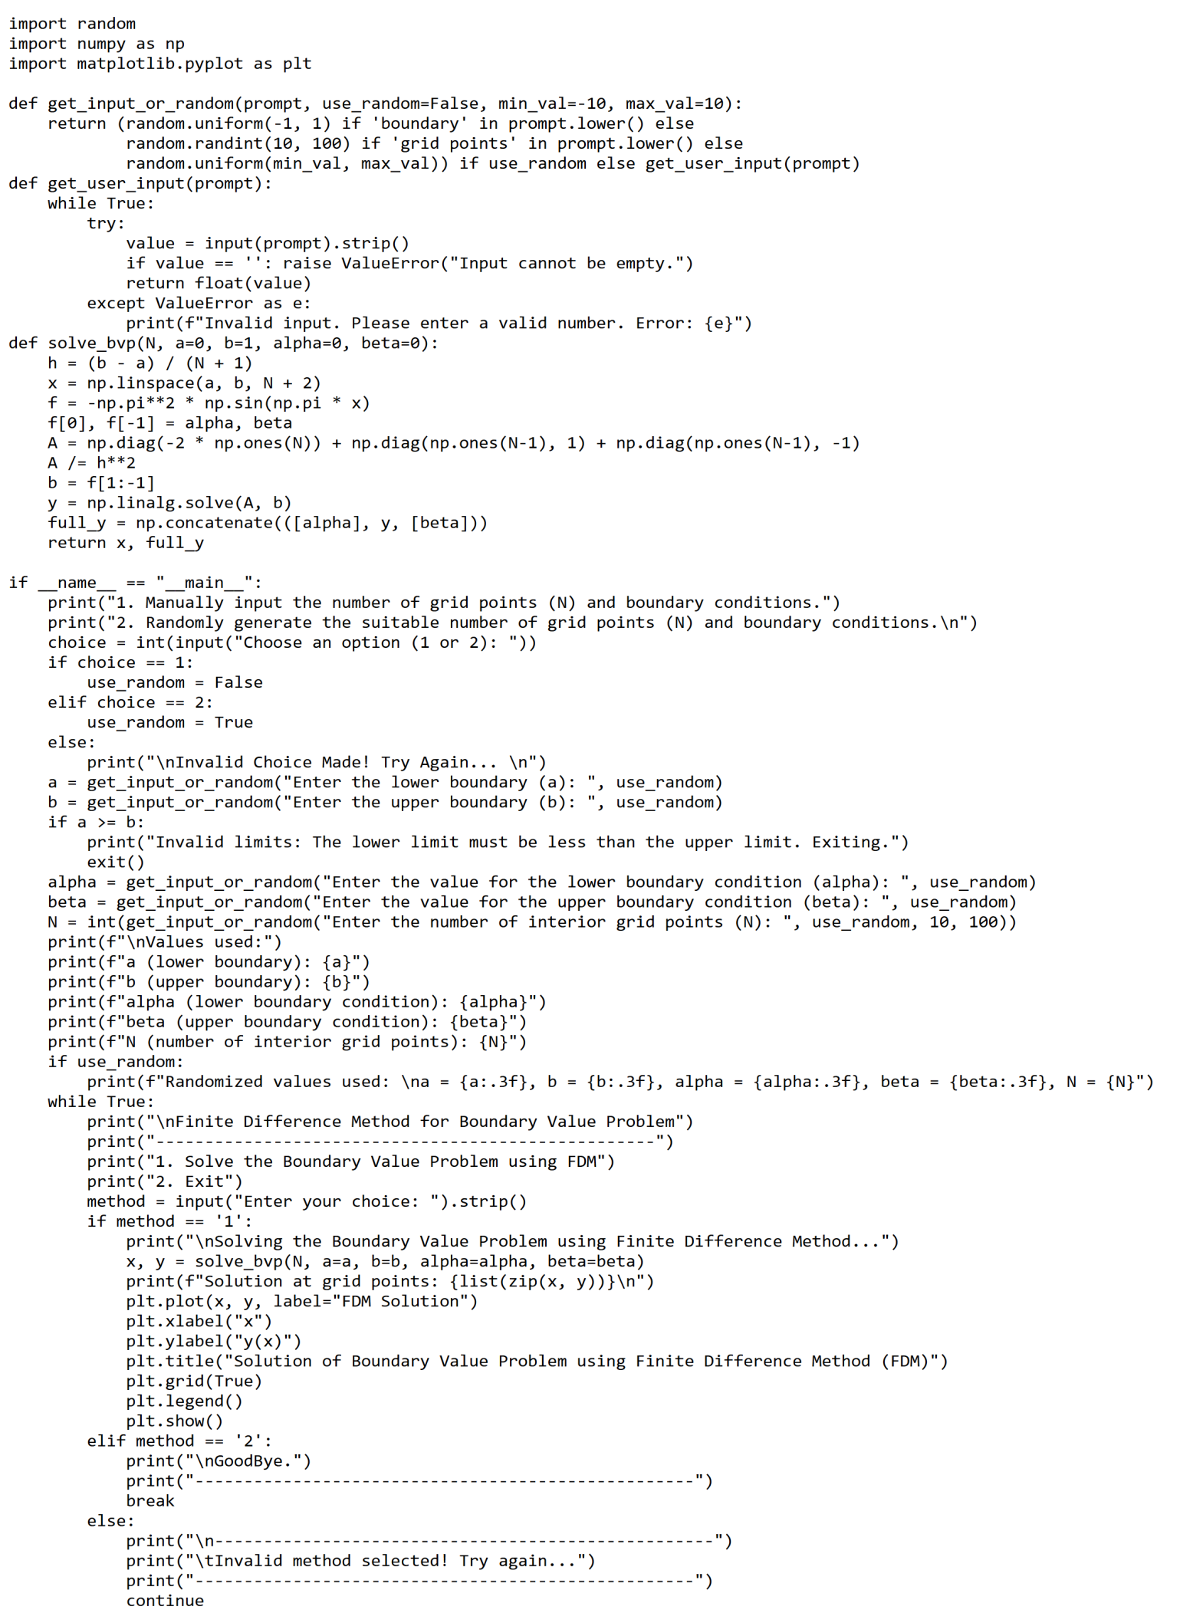

**Output:**